**FORMAN CHRISTIAN COLLEGE (A CHARTERED UNIVERSITY)**



**Information Security**

**Section B**

|  |  |
| --- | --- |
| Name | Umar Javed |
| Roll number | **241546728** |

**Basic msfvenom:**

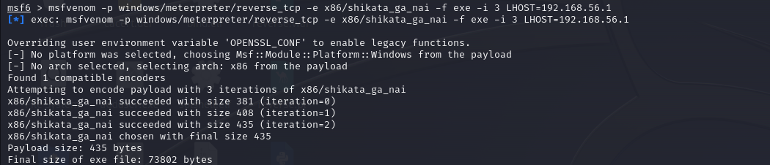

**Listing:**

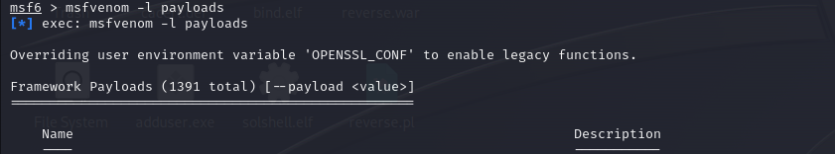



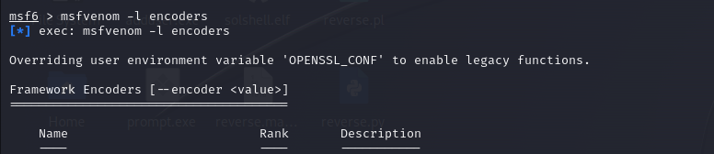

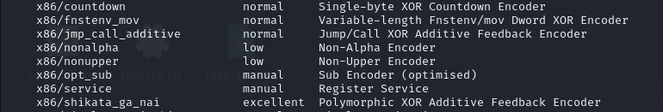

**Common params when creating a shellcode:**

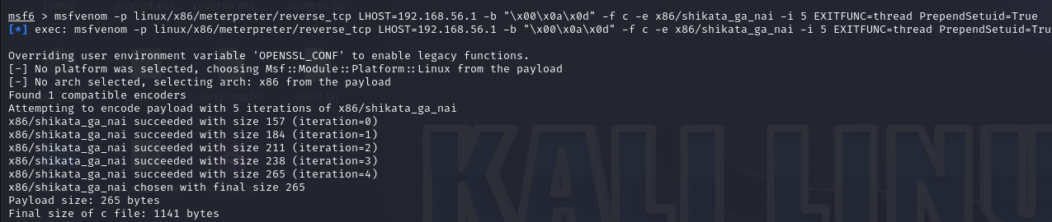

**Windows**

**Reverse Shell, Bind Shell, Create User, CMD Shell:**

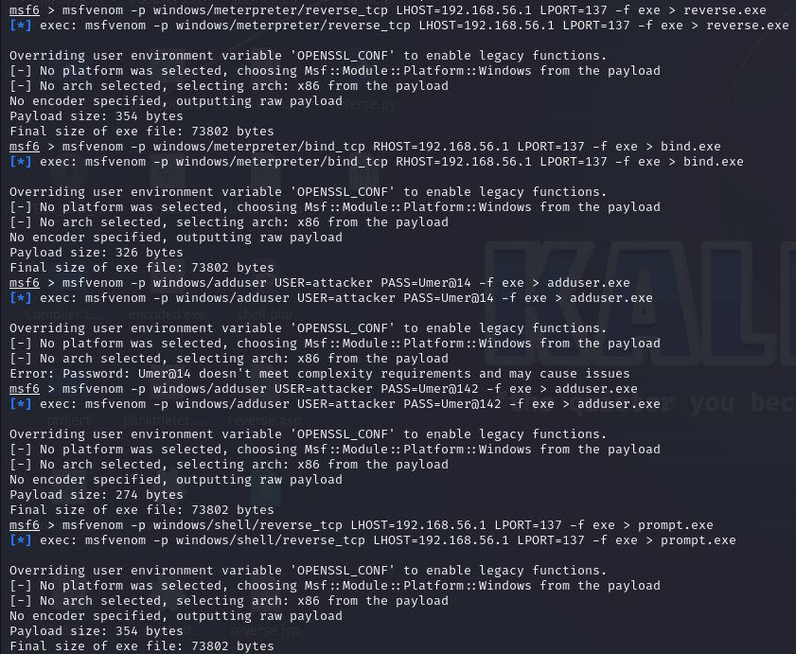

**Execute Command, Encoder, Embedded inside executable:**

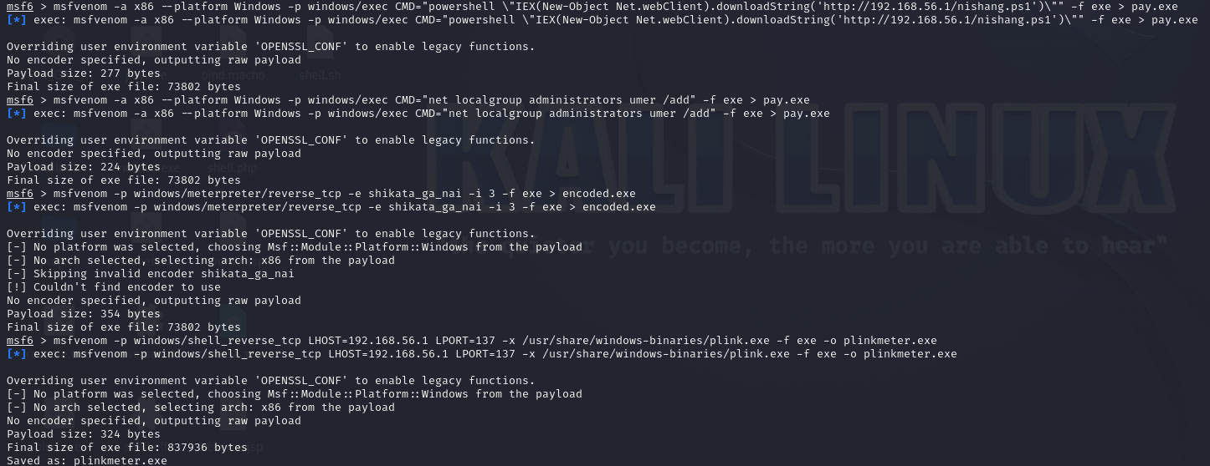

**Linux Payloads**

**Reverse Shell, Bind Shell, SunOS:**

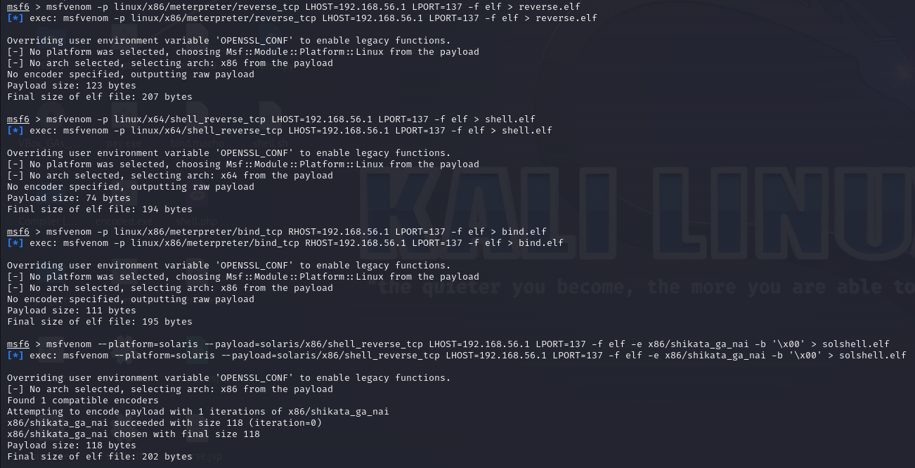

**MAC Payloads**

**Reverse Shell, Bind Shell:**

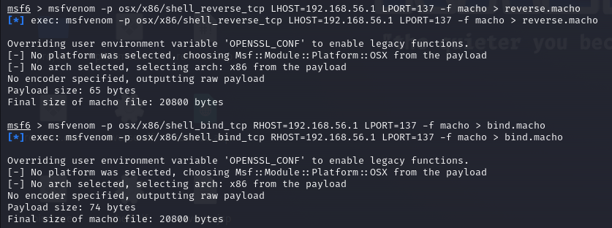

**Web Based Payloads**

**PHP, ASP/x, JSP, WAR, NodeJS:**

**Reverse shell:**

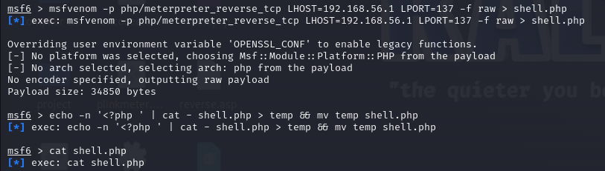

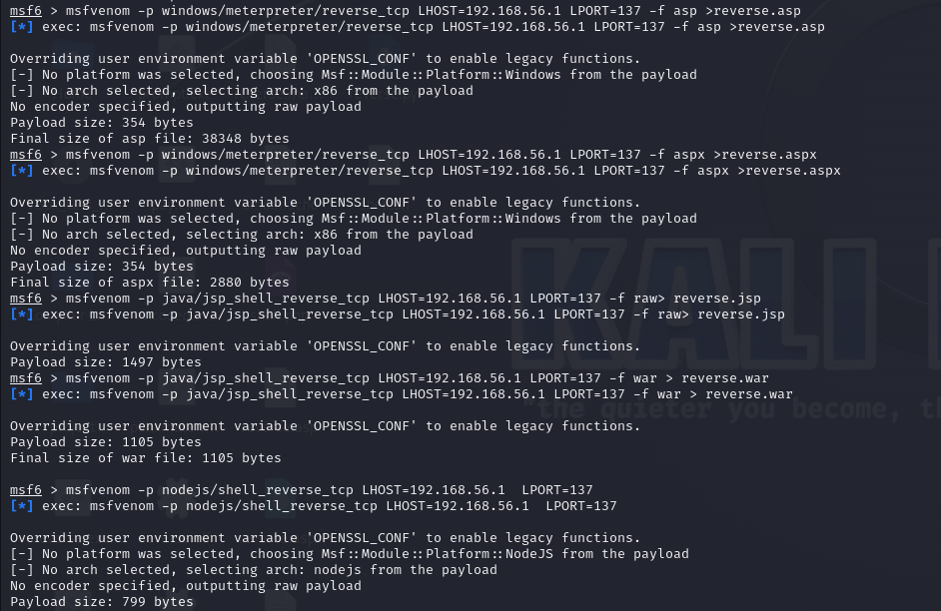

**Script Language payloads**

**Perl, Python, Bash:**

